Biography of Mr. Suresh Ramachandra
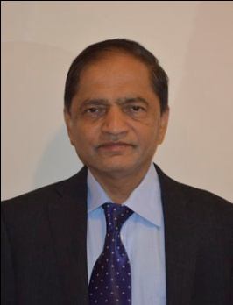
Suresh Ramachandra is actively involved in business and entrepreneurial activities in the Washington DC metropolitan area. He was the CEO and President of MTECH, Director of Info Soft Systems, Chairman of US Indian American Chamber of Commerce, and executive board member of American Society of Engineers of Indian Origin (ASEI). He has demonstrated a successful leadership in running a small business and understands many challenges faced by small business community. Suresh was also on the board of directors for many small businesses and advised them leading to a successful path. Professionally Suresh Ramachandra has worked in the NASA space program for 20+ years. He was US National delegate for ISO-TC211, and NASA representative on Committee on Earth Observing Satellites over a period of 12 years. He has contributed to space program in many capacities was the Principal Investigator, Manager on multiple projects. He has authored number of papers and articles in professional journals and in a book.
He was also involved in many non-profit organizations. Suresh Ramachandra is currently the President of NAVIKA, a non-profit NRI organization. He is a resident of Washington DC metropolitan area for the last 30+ years and has been involved in multiple voluntary organizations. To mention a few important ones: Kaveri Kannada cultural association as President and Chairman for Board of Trustees. Vice President of AKKA, Chairman of AKKA International Conference held in Baltimore, MD among many others.

